**Mock In-Class 3**

Create a new solution called Mock In-Class 3. Make sure you create a new Project for every question!

**Question 1 - Zodiac Calendar**

Build a program that lets a user enter their year of birth (between 1900 and 1999) and you will tell them what their Zodiac animal is for that year. The animals and some of the years associated (between 1900 and 1999) with them are listed below.

|  |  |
| --- | --- |
| **Animal** | **Years** |
| Rat | 1960, 1972, 1984, 1996 |
| Ox | 1961, 1973, 1985, 1997 |
| Tiger | 1962, 1974, 1986, 1998 |
| Rabbit | 1963, 1975, 1987, 1999 |
| Dragon | 1964, 1976, 1988 |
| Snake | 1965, 1977, 1989 |
| Horse | 1966, 1978, 1990 |
| Goat | 1967, 1979, 1991 |
| Monkey | 1968, 1980, 1992 |
| Rooster | 1969, 1981, 1993 |
| Dog | 1970, 1982, 1994 |
| Pig | 1971, 1983, 1995 |

Test your program with the following test plan:

|  |  |
| --- | --- |
| **Test Data** | **Expected Result** |
| 1990 | Horse |
| 1996 | Rat |
| 1995 | Pig |
| 1989 | Snake |

Your output should match this exactly:

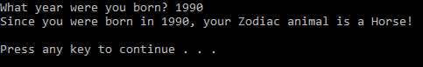

**Question 2 – Provinces**

Build a program that lets the user enter the name of a province (not territories), and then tells them that province’s slogan. If they enter an incorrect province, tell them the slogan is unknown. The slogans are provided below.

|  |  |
| --- | --- |
| **Province** | **Slogan** |
| Alberta | Wild Rose Country |
| British Columbia | Beautiful British Columbia |
| Manitoba | Friendly |
| New Brunswick | Picture Province |
| Newfoundland and Labrador | A World of Difference |
| Nova Scotia | Canada’s Ocean Playground |
| Ontario | Yours To Discover |
| Prince Edward Island | Canada’s Green Province |
| Quebec | Je me souviens |
| Saskatchewan | Land of Living Skies |

Test your program with the following test plan:

|  |  |
| --- | --- |
| **Test Data** | **Expected Results** |
| alberta | Wild Rose Country |
| NOVA SCOTIA | Canada’s Ocean Playground |
| BritishColumbia | Unknown |
| québec | Unknown |

Your output should match this exactly:

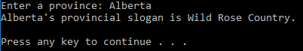

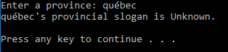

BONUS:

Make your program in a way that tells the user if their input wasn’t recognized instead of displaying Unknown!

